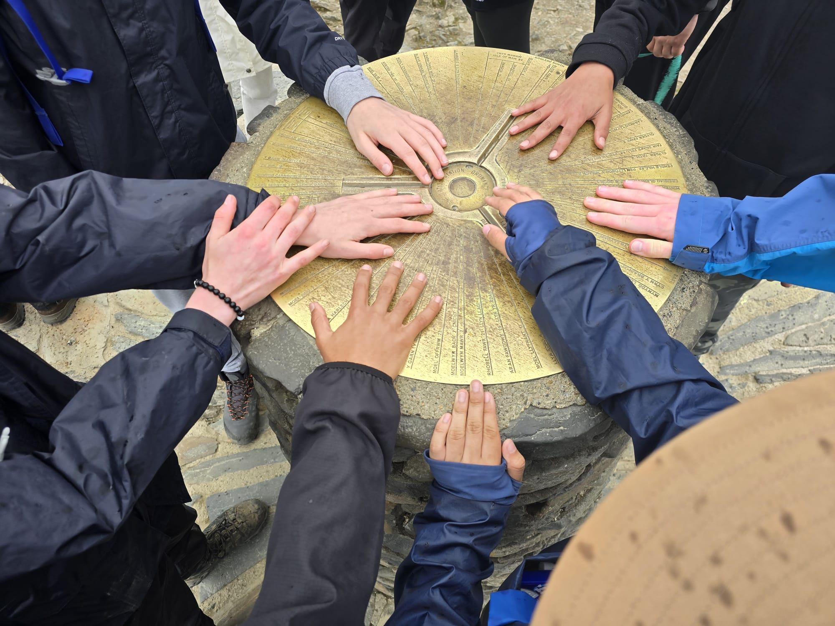
ST THOMAS MORE
LANGUAGE COLLEGE
CADOGAN STREET CHELSEA LONDON SW3 2QS
OPEN MORNINGS
TUESDAY 20 October 0920 - 1045
THURSDAY 22 October 0920-1045
Booking is essential to join these tours
https://forms.gle/2VLHQq6koAUHNBua8
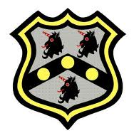
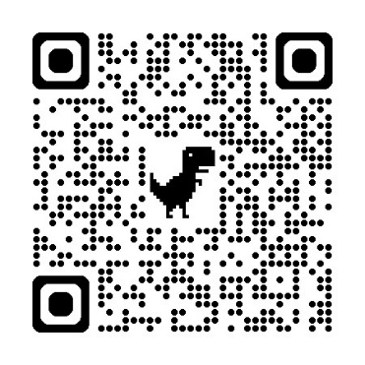
TUBE: SLOANE SQUARE STATION
BUS: DUKE OF YORK SQUARE

